**#1. Clone https://gitlab.com/PranavVK28/qrcodescanner.git repo.**

**#2. Open the project with Visual Studio Code (https://code.visualstudio.com/download)**

**#3 Go to View-> Terminal**

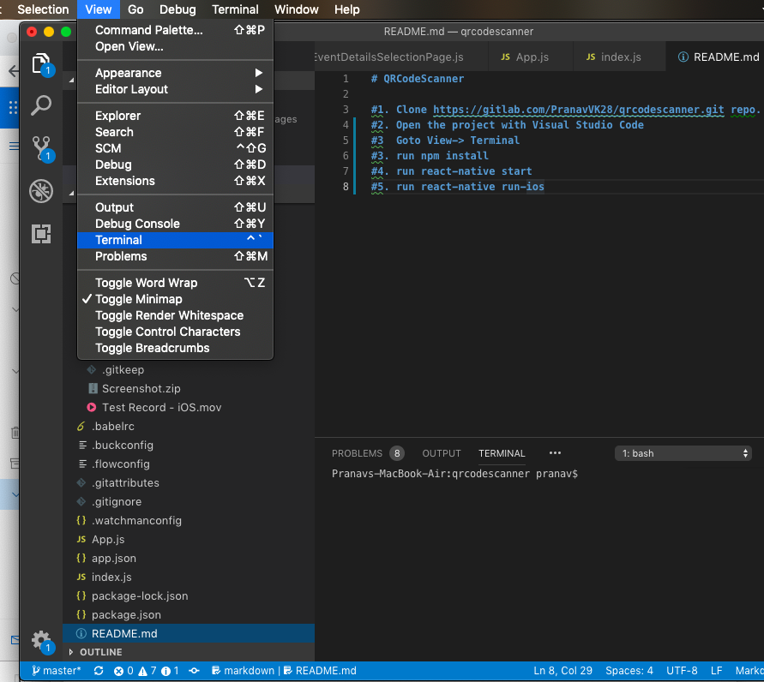

**#3. run npm install**

**#4. run react-native start**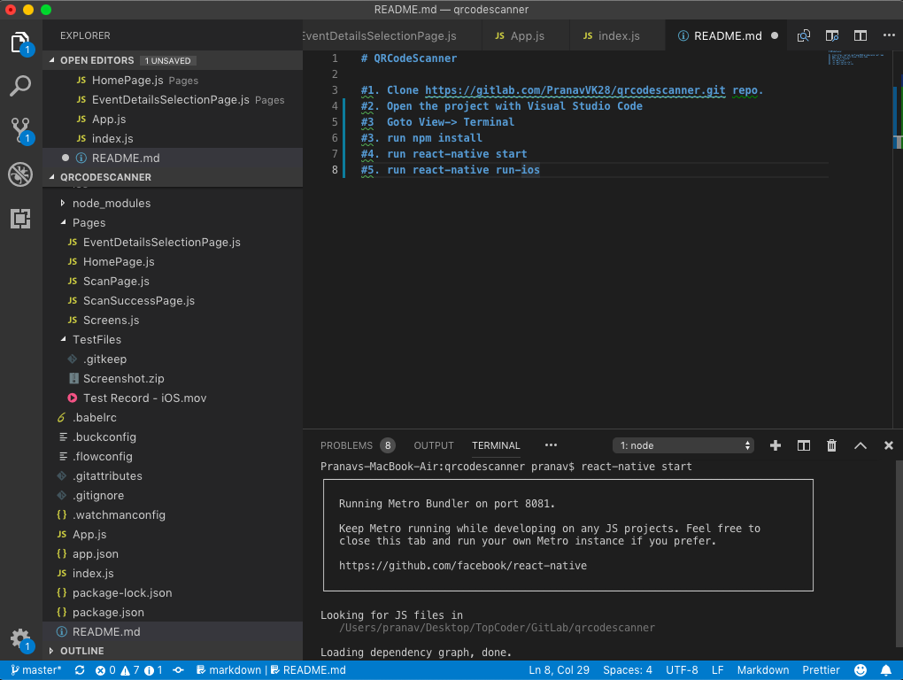

**#5. Add New terminal by clicking on + Button**

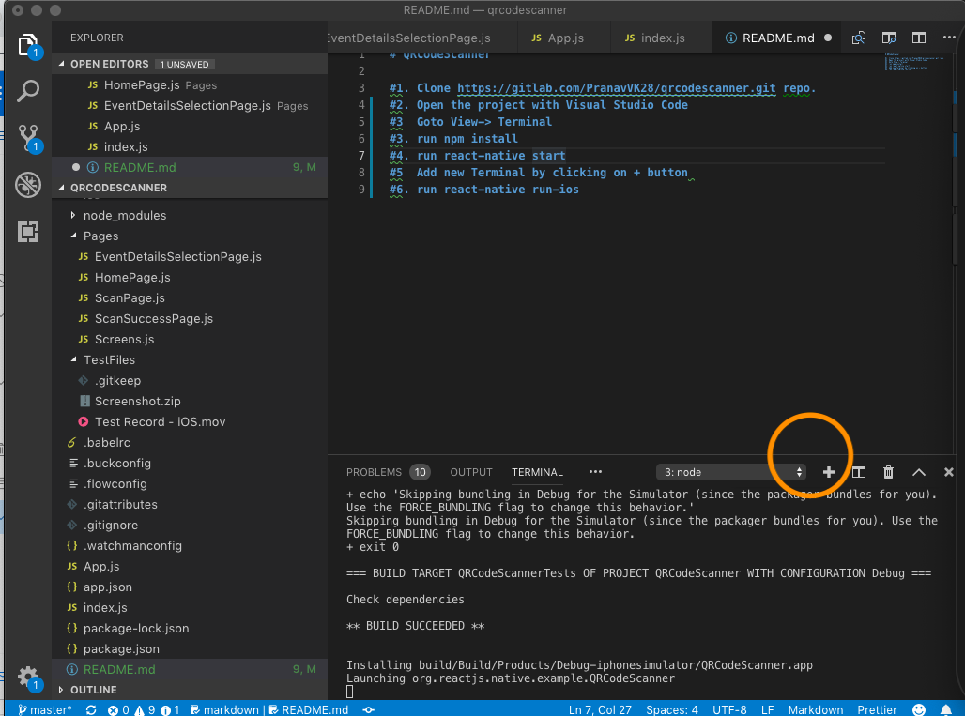

**#6. run react-native run-ios**

